Jenkins Login and Artifacts

[Joel.robinson@hp.com](mailto:Joel.robinson@hp.com) April 11 2017

URL=<http://172.20.209.42:8080/login?from=%2F>.

[UN=joel.robinson@hp.com](mailto:UN=joel.robinson@hp.com)

PW=Jenkins

# **Dashboard View Builds History**

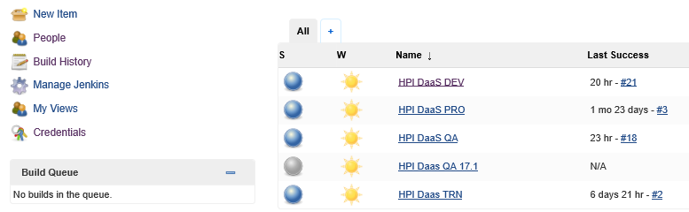

Project HPI DaaS QA

